Waabanong Weekly Update
Delivered July 20, 2026
Week of July 13 to 17, 2026
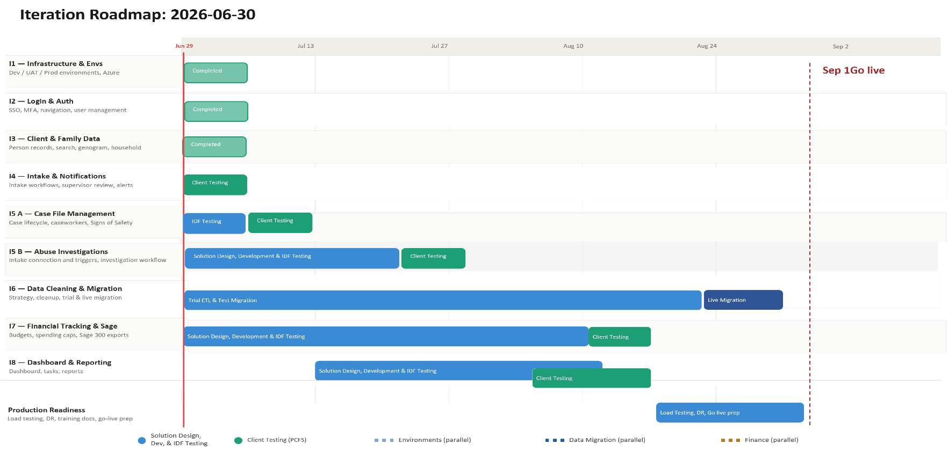

Iteration | Status | Current phase | Notes
I1 - System Infrastructure & Environments | In progress | PCFS Testing | No changes this week
I2 - Login & Authorization | In progress | PCFS Testing | No changes this week
I3 - Client, Member & Family Data | In progress | PCFS Testing | No changes this week
I4 - Intake Management & Automated Notifications | In progress | PCFS Testing | Development and bug fixes continue
I5 A - Case File Management & Signs of Safety | In progress | Development | No activity this week
I5 B – Abuse Investigations | In Progress | Solution design | No activity this week
I6 - Data Migration | In progress | Planning | Anonymization approach for production-data snapshot still being evaluated
I7 - Financial Tracking & Exports for Sage | In progress | Solution design | No new activity this week
I8 - My Dashboard & Reporting | Not started

Project Management & General
Weekly Progress
- End-of-project planning session (Jul 13) covered three go-live readiness threads: screen-by-screen training-video documentation, production-database anonymization for migration testing, and the go-live order-of-operations/timeline — see I6 for the migration piece. IDFusion will follow up with Rob on training-video scope and send Ross a detailed go-live sequencing plan.
- A pre-go-live stress test (simultaneous-login load test) will be scheduled as part of go-live activities.
- Ross raised interest in bringing event management and Community Circle of Care functionality into near-term planning; IDFusion confirmed the team does not have capacity for this within the current schedule and will follow up with a roadmap conversation once PCFS gathers detailed requirements internally.
I1 - System Infrastructure & Environments
Features
- Set up Development, Testing, and Production environments
Weekly Progress
- No infrastructure changes this week.
I2 - Login & Authorization
Features
- Microsoft 365–based authentication
- User login
Weekly Progress
- No authentication changes this week.
I3 - Client, Member & Family Data
Features
- Centralized person records (children, adults, limited profiles)
  - Duplicate prevention
- Family and household structures
  - Multi-generation relationships
- Reciprocal relationship logic
- Global search across people and families
Weekly Progress
- No changes this week.
I4 - Intake Management & Automated Notifications
Features
- Structured intake workflows with mandatory fields
- Intake status tracking and lifecycle
- Supervisor review and approval processes
- Ability to resolve intake without opening a case
- Escalation from intake to case creation
- Printable intake records
- Automated notifications:
  - In-application alerts
  - Defined external channels (email/messaging)
Weekly Progress
- Development and bug fixes continue for Intake Management.
I5 A - Case File Management & Signs of Safety
Features
- Case file creation and lifecycle management
- Assignment of caseworkers and supervisors
- Case reassignment with approval
- Signs of Safety–aligned workflows, including:
  - Placement
  - Structured assessments
  - Safety goals and planning
  - Ongoing review checkpoints
- Visibility into historical and related cases
- Case notes for visits, services, and interactions
- Communication tracking across intake and case contexts
  - Document management: Person, Intake & Case
Weekly Progress
- No new developments this week.
I5 B – Abuse Investigations
Features
- Triggers and integration with Intake module
- Investigation workflow
- Investigation document management

Weekly Progress
- No new developments this week; solution design continues.
I6 - Data Cleaning and Migration
Features
- Develop a data migration strategy from FAMCare into Waabanong
- Support PCFS as they perform data cleanup
- Execute trial data migrations in a sandbox environment
- Perform live data migration
Weekly Progress
- Production-data anonymization approach still being scoped — IDFusion (Varun) is evaluating a data-obfuscation tool (Data Veil) and consulting on alternative approaches, alongside finalizing exactly which data fields need to migrate from FAMCare.
- PCFS agreed to pre-identify key test cases so that, once the database import is complete, both teams can perform side-by-side checks confirming all required data imported correctly and no sensitive information remains exposed.
- Target timeline for obtaining a scrubbed production-data snapshot has passed without resolution; this remains the primary blocker for migration testing and is being actively worked.
I7 - Financial Tracking & Exports for Sage
Features (Potential scope may include)
- Intake-level emergency supports
- Case-level budgets
- Spending caps and approvals
- Export files to import into Sage 300
Weekly Progress
- No new activity this week; finance module remains in solution design.
I8 - My Dashboard & Reporting
Features (Potential scope may include)
- My Dashboard (simple, quick reference to key items)
- Tasks & alerts
- Reporting (if required and not covered in other iterations)
Weekly Progress
- Future iteration per schedule (no dashboard/reporting work this week).

